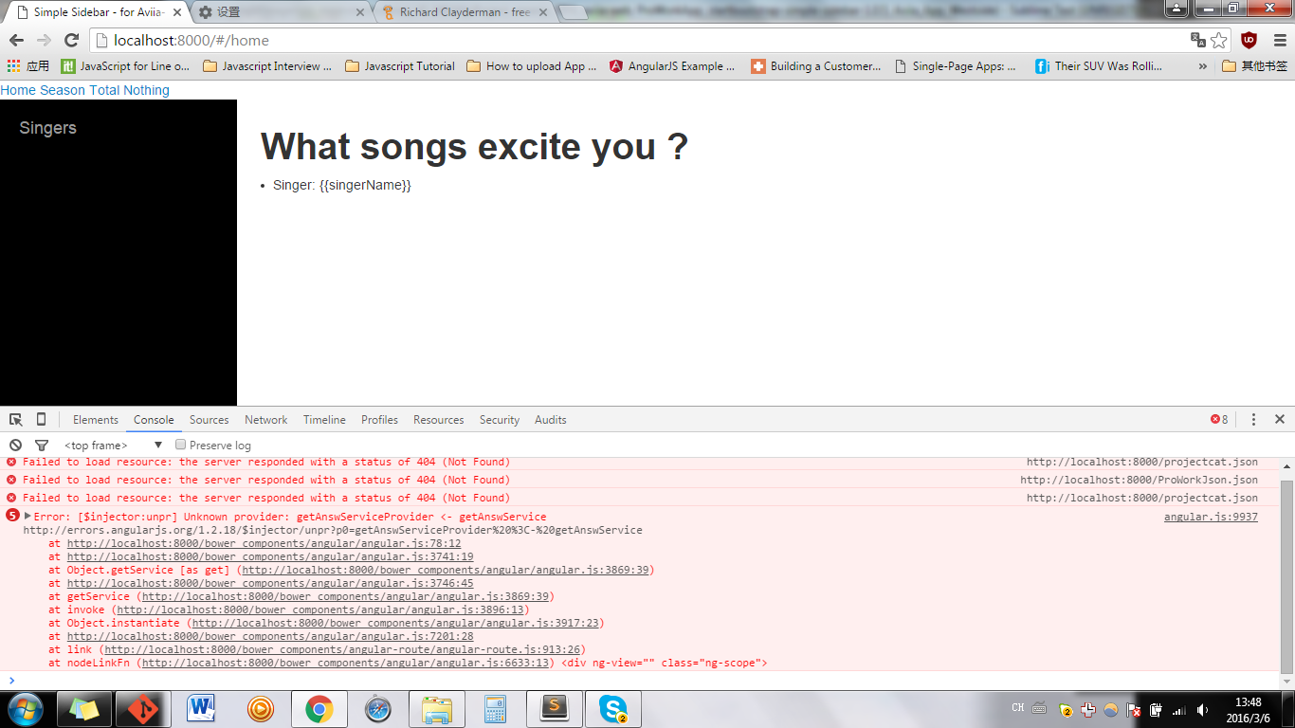

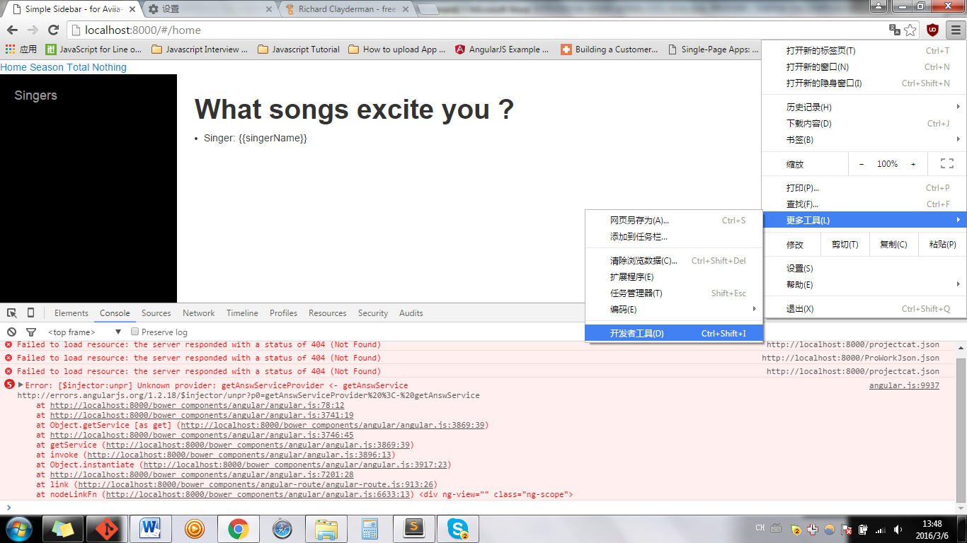

Open developer tools

See: error: getServices

\*\*\*\*\* check with your controller, see the all the modules added to this controller